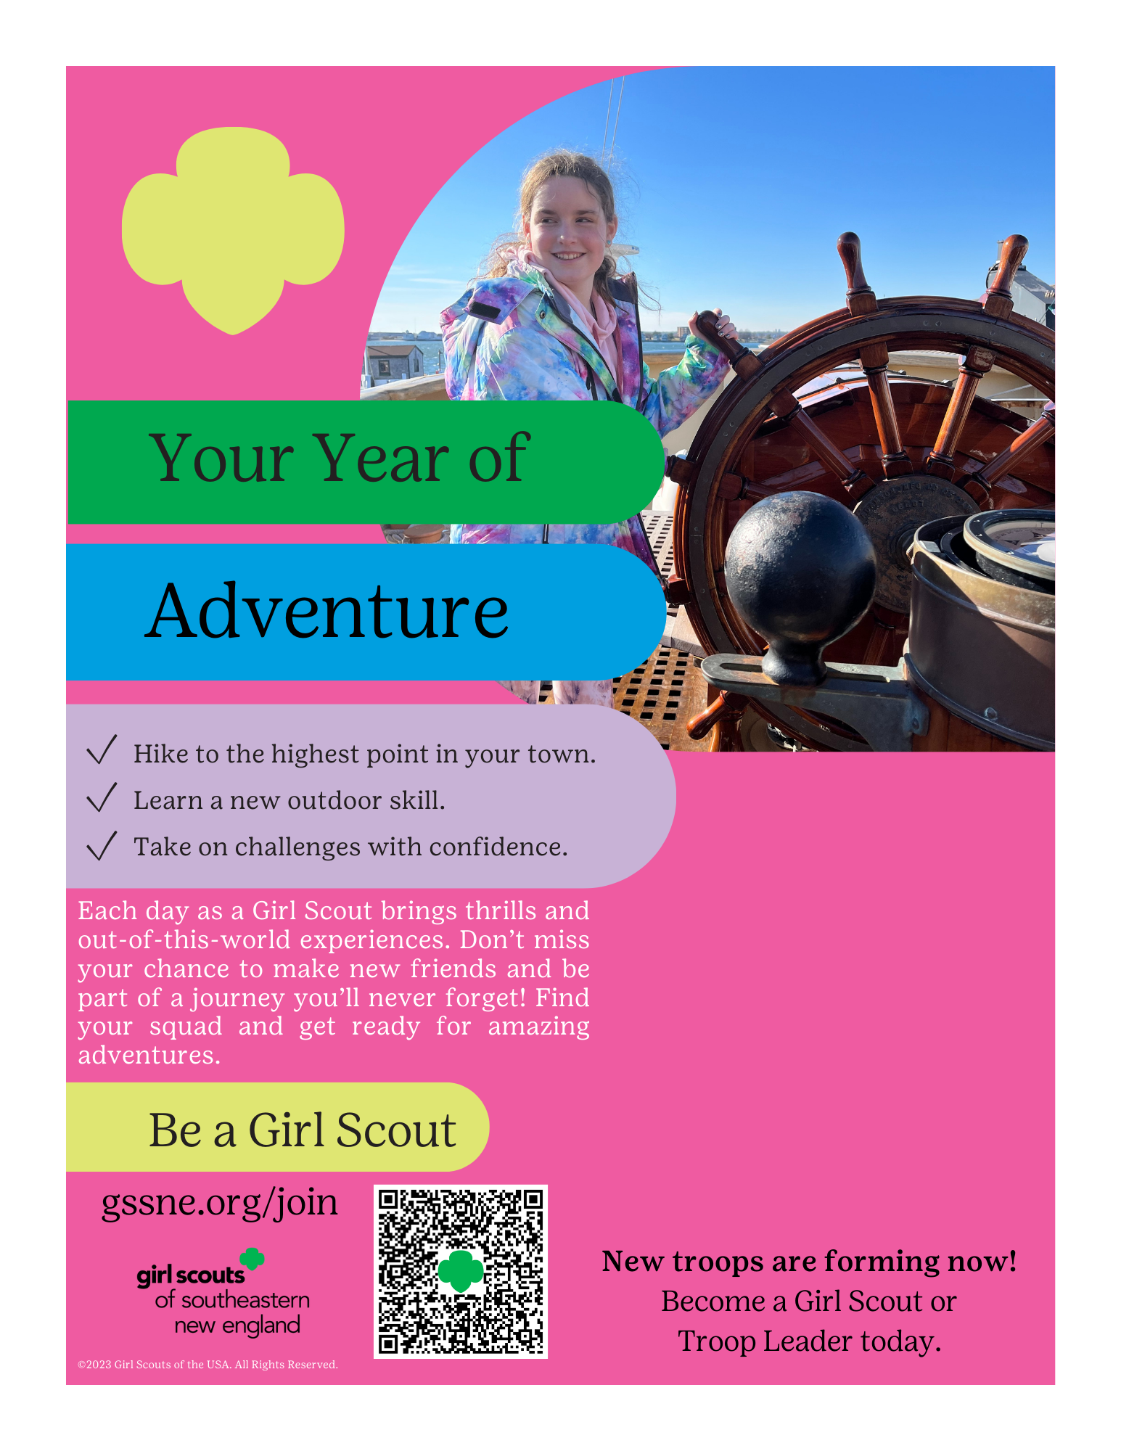

Come to our Girl Scout Information Session:

Date: EDIT HERE

Time: EDIT HERE

Place: EDIT

For more information, contact:

EDIT HERE

TEXT BOX IS EDITABLE AS YOU SEE FIT.