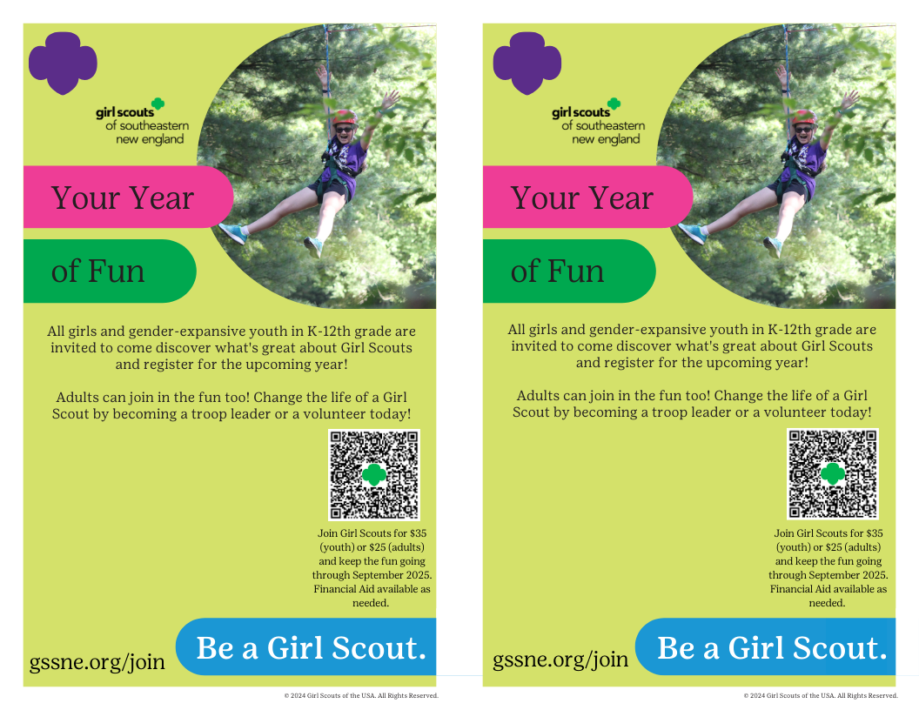

Event Name

Date and Time

Location Name and Address

Any other information you want to share

Event Name

Date and Time

Location Name and Address

Any other information you want to share